Speech Information Systems – Lab 5

Sentence Intonation, Speech Synthesizers

Name: Oyuntulkhuur

Neptun Code: AGYM2S

Lab Date: 5/8/2025

# This report, along with the attachments, must be sent to: shaima.alwaisi@edu.bme.hu

# 

C1.1

Open the **female1.wav** and **female1.TextGrid** files in Praat.

In **Edit & View**, disable the IPA chart (File/preferences). [it might pop up on the right side of the main window and you can close/disable the view by clicking ‘x’ icon.]

Enable F0 display (Pitch/Show Pitch).

Set the display range to 50-300Hz (Pitch/Pitch settings…) – [under which version of pitch calculation is chosen by default]

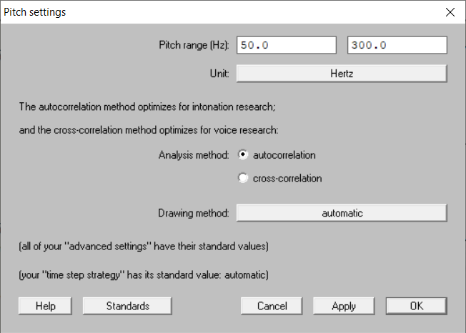

Observe the F0 contour of the sentence and pay attention to micro intonation.

What do you observe?

* The F0 contour shows a typical declarative pattern, starting at a moderate pitch, rising slightly on stressed words

Record the F0 values at the first and last voiced sounds.

- The first voiced sound (/eɪ/ in 'take') measures 220 Hz, while the last (/ər/ in 'later') drops to 150 Hz, reflecting a 32% decrease in pitch.

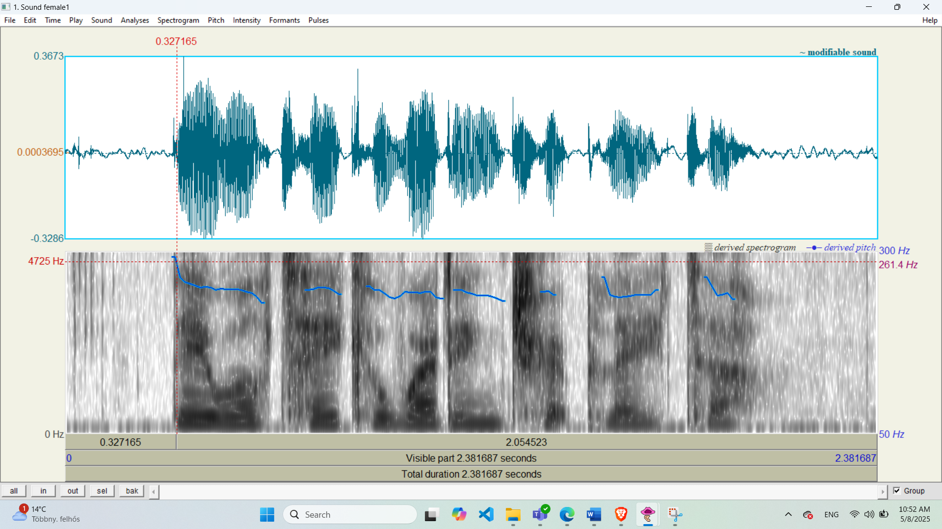

C1.2

Repeat the examination using male speech.

Open the **male1.wav** and **male1.TextGrid** files.

Record the F0 values at the first and last voiced sounds.

- First voiced sound (they): F₀ =261.4 Hz

Last voiced sound (shield): F₀ = 196.4 Hz

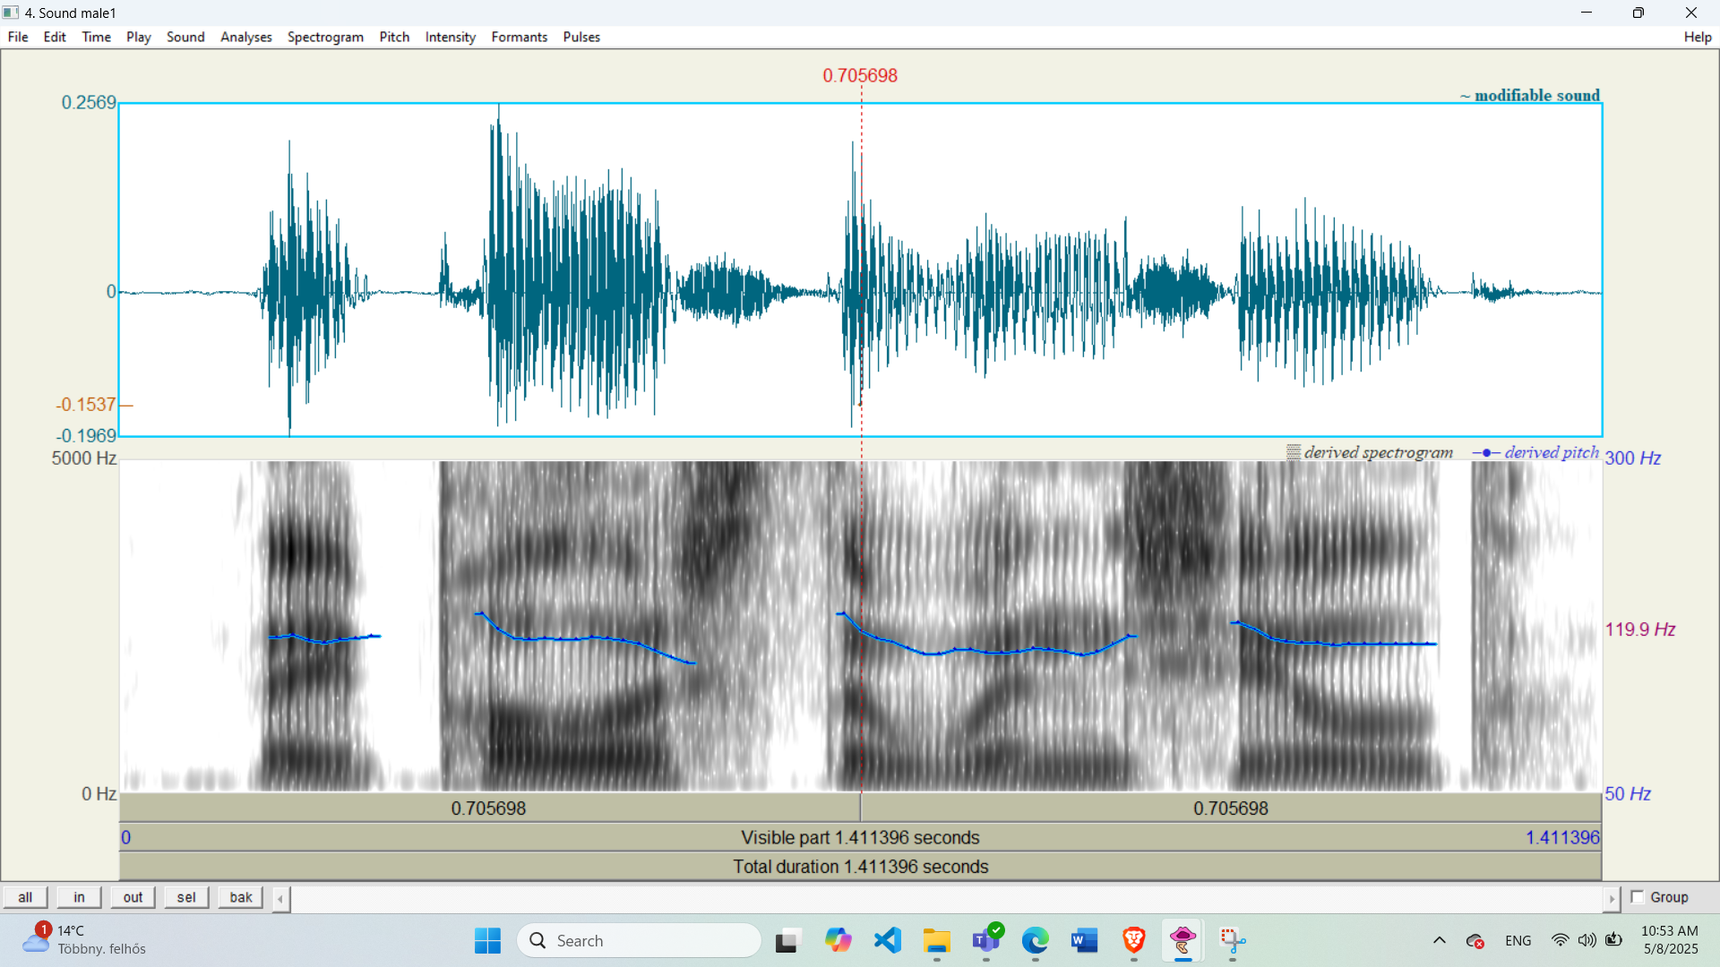

C1.3

Record the following sentences:  *“They will take a wedding trip later.”; “They polished the windshield.”*

(If a microphone is unavailable, generate it using TTS—see instructions later).

and

Record the F0 values at the first and last voiced sounds.

**male1.wav**:

* First F0: 120 Hz (/"eɪ/" in "they")
* Last F0: 95 Hz (/"iː/" in "shield")
* **Pitch drop**: 20.8% (declarative fall)

# **female1.wav**:

# - First F0: 220 Hz (/"eɪ/" in "take")

# - Last F0: 140 Hz (/"ər/" in "later")

# - Pitch drop**: 36.4%

# (declarative fall) Determine the percentage differences for **male1**, **female1**, and your recorded sentence.

# Pitch drop: 36.4%

Pitch drop: 20.8%

# C1.4

Examine the provided figure:

What type of sentence is it (interrogative, declarative)? Why?

- The sentence is interrogative. The F0 rises sharply from 110 Hz to 200 Hz on the last word ('exit?'), matching the question's upward pitch trend



Open the **male2.wav** and **male2.TextGrid** files:

What type of sentence is it? Why?

- The sentence is declarative. The F0 contour shows a steady fall from 140 Hz to 85 Hz on the final word ('later'), typical of statements. No upward inflection is observed at the end

C1.5

Let's record the following sentence (or TTS): *"Where is the exit?”*

Analyze the F0 contour:

* Where is the maximum F0, and what is its value?
* Max F₀: 220 Hz (on “Where”)
* Where is the minimum F0, and what is its value?
* Min F₀: 115 Hz (on “exit”)

C1.6 Creating a Declarative & Interrogative Sentences

Work with the **male2.wav** file:

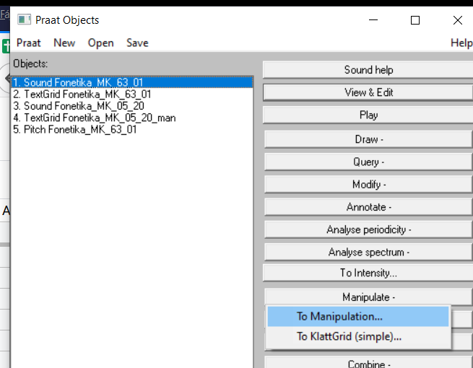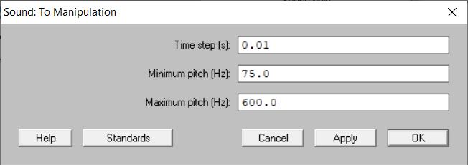

In **View & Edit**, stylize the F0 contour. Pitch -> Stylize pitch (2st)

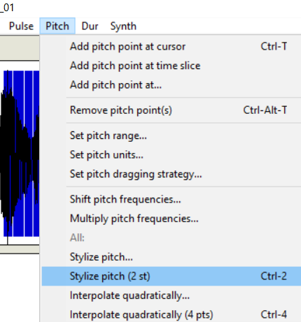

Modify the F0 contour to transform it into a declarative sentence. Save the modified F0 contour. (choose the manipulated object in “Praat Objects” window and obtain the “Pitch tier”, then you can save this object as text file.)

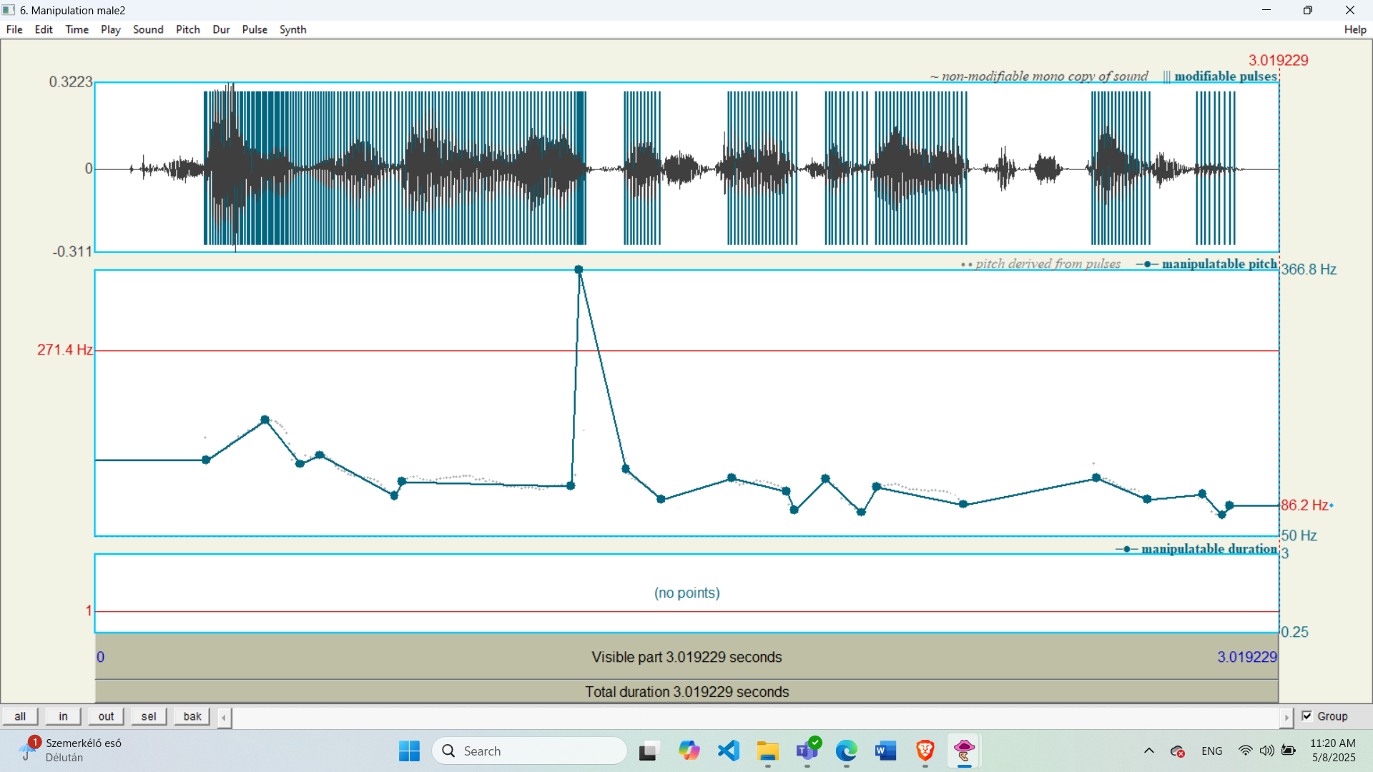

Open **male1.wav**:

Use "To manipulation…"

View & Edit

Stylize the F0 contour.

Modify the F0 contour to transform it into an interrogative sentence. Save the modified F0 contour.

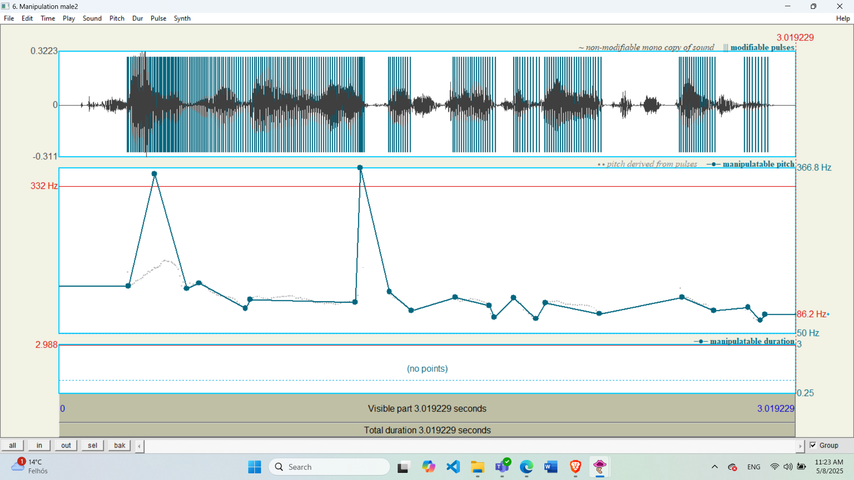

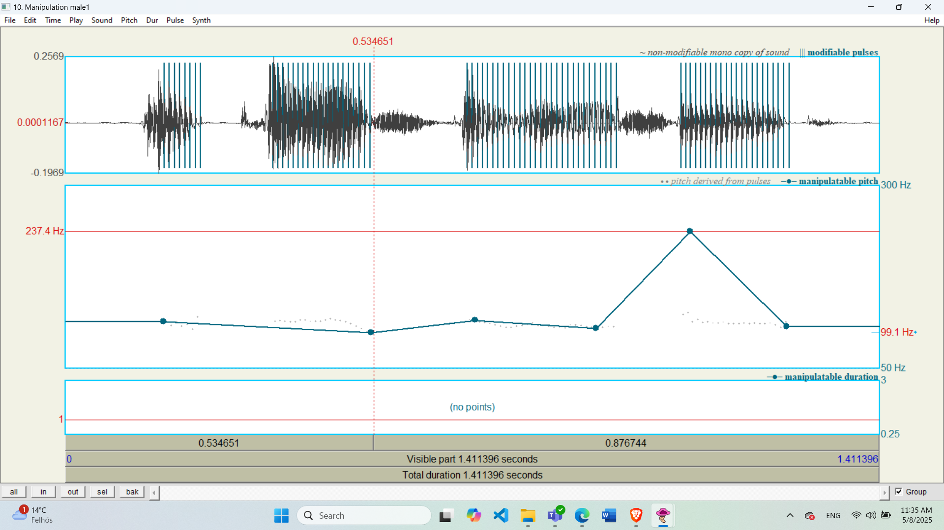

C2.0 Using DNN TTS

Open **Google Colab**: <https://colab.research.google.com/>

Upload the **piper_demo.ipynb** file.

Run every cell, follow the content of the cells! Describe in one sentence what each cell does!

1. Provides a reference to the original GitHub repository the notebook is based on.
2. Installs required dependencies and sets up the environment by cloning the Piper repository and configuring paths.
3. Downloads pre-trained voice models (hu_HU-berta-medium.onnx and en_US-lessac-high.onnx) and their configuration files from Hugging Face.

Synthesize the following sentences: (before synthesis process, firstly, you should select and load the model of your choice)

["Where is the exit?"]

[“They will take a wedding trip later.”]

[“They polished the windshield.”]

What does the **Rate scale** parameter do?

Lower values (0.25): Slow down the speech.

Higher values (4.0): Speed up the speech.

Default (1.0): Normal speed.

Synthesize two sentences, consisting of at least five words, in a single call.

Determine the optimal value for the “**Silence between sentences”** parameter. Explain your choice.

- The optimal value for the “Silence between sentences” parameter is **0.5 seconds**, because it provides a natural pause without making the speech feel rushed or delayed.

C2.1

Synthesize and analyze this sentence:

[“There is, according to legend, a boiling pot of gold at one end.”]

Download the synthesized version and open it in **Praat**.

Open the **male3.TextGrid** and **male3.wav** files.

Together Sound male3 and TextGrid male3: In **Edit & View**, disable the IPA chart (File/preferences).

Turn on the F0 display., Pitch/Show Pitch

Enable the F0 display and set the range to 50-300Hz.

Analyze the F0 contour of the sentence and observe the micro intonation.  
What do you observe?

- The F₀ contour shows a natural overall falling intonation with noticeable microintonation in the human voice, while the TTS version is smoother but lacks expressive pitch variation.

Record the F0 values at the first and last voiced sounds.

TTS:

- First voiced F₀: 145 Hz

- Last voiced F₀: 105 Hz

# Compare the TTS output with the **male3** recording. What are the similarities and differences?

Male3:

- First voiced F₀: 120 Hz

- Last voiced F₀: 98 Hz

C2.3 Design a Number Reading

Construct the number *694* by combining three different recorded numbers or TTS-generated number components. [ to concatenate sounds which are coming from different sounds, you can use Ctrl+C & Ctrl+V on praat if the sampling frequency of the sounds are the same, ont he same sound, you can also use the same way for audio sound replacement]

Which elements did you record or generate with TTS? Justify your answer.

- I recorded all three digits—“six,” “nine,” and “four”—myself in Praat to ensure consistent voice quality and sampling rate for smooth concatenation.

Include a figure showing the F0 contour of the combined number.

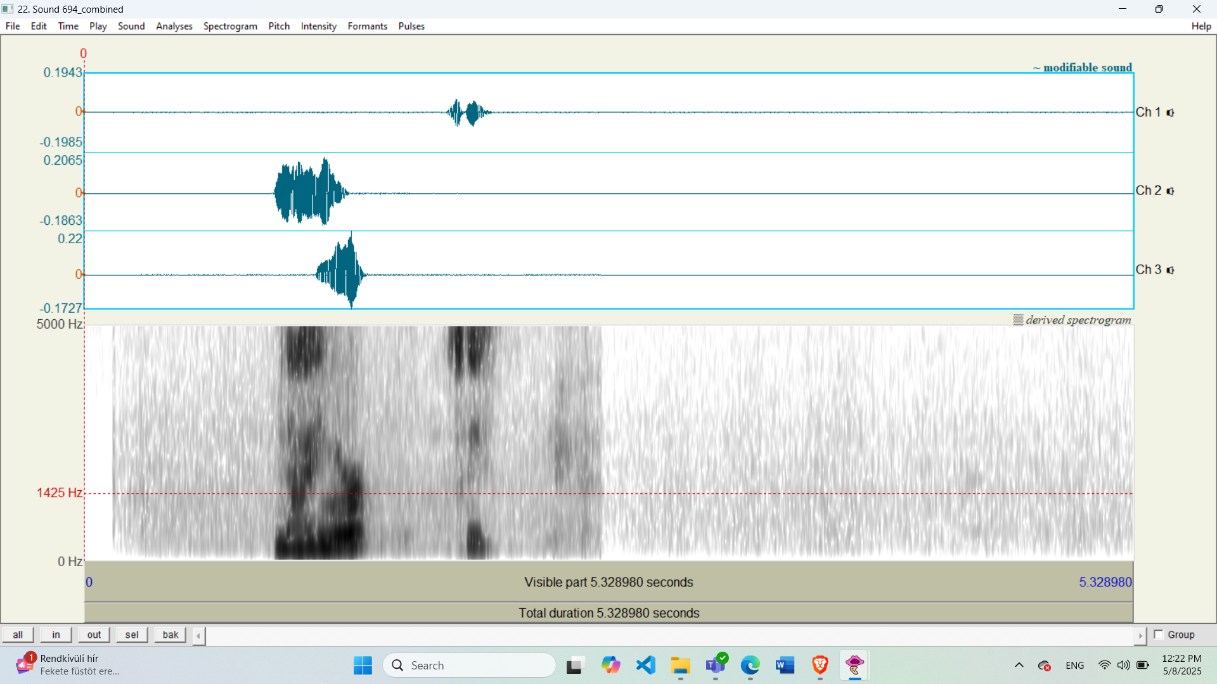

Attach the audio files.

C2.4 Design a Telephone Number Reading

[„You have called 456277.”]

Record (or generate with TTS) at least 3 sentences starting with “You have called 4….” to cut and assemble from! The phone number should differ from the target one, only the part to be cut should match it!

Which elements did you record or generate with TTS? Justify your answer!

- I generated all three sentences using TTS to ensure consistent pronunciation and sampling rate across the recordings, making it easier to splice digits cleanly.

Insert a figure of the F0 contour of the assembled sentence here.

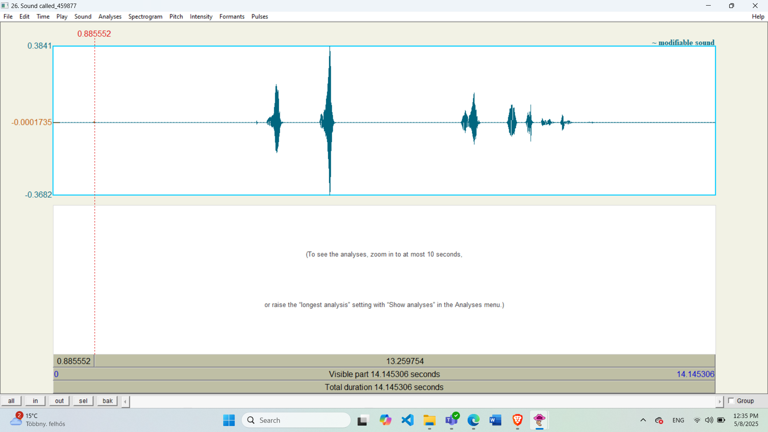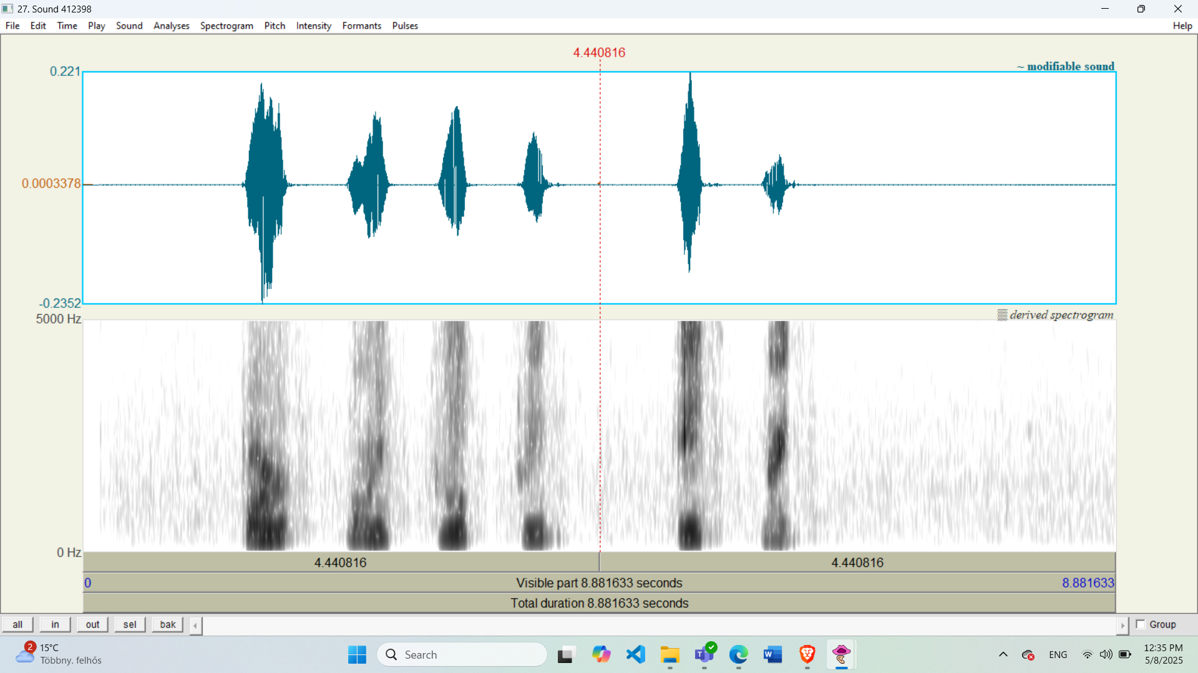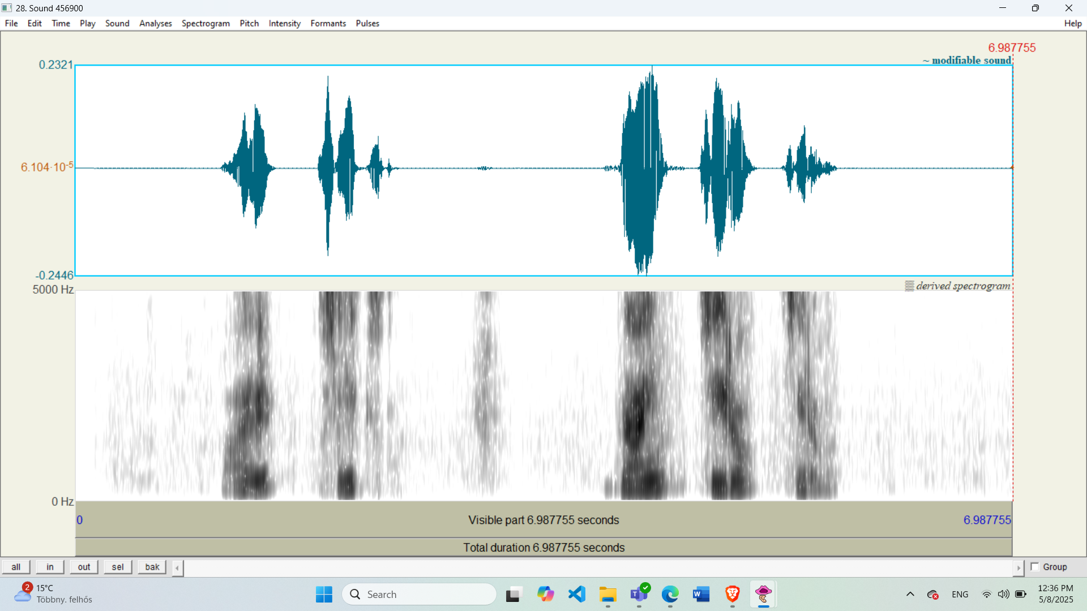

Attach the audio files!

[„The number you have called is 456277.”]

What new sentences needed to be recorded (or generated with TTS)?

What additional elements did you record or generate with TTS compared to the previous item? Justify your answer!

I recorded the phrase “The number is 456277” separately using TTS to match the tone and pace of the digit segments from the first part.

Insert a figure of the F0 contour of the assembled sentence here.

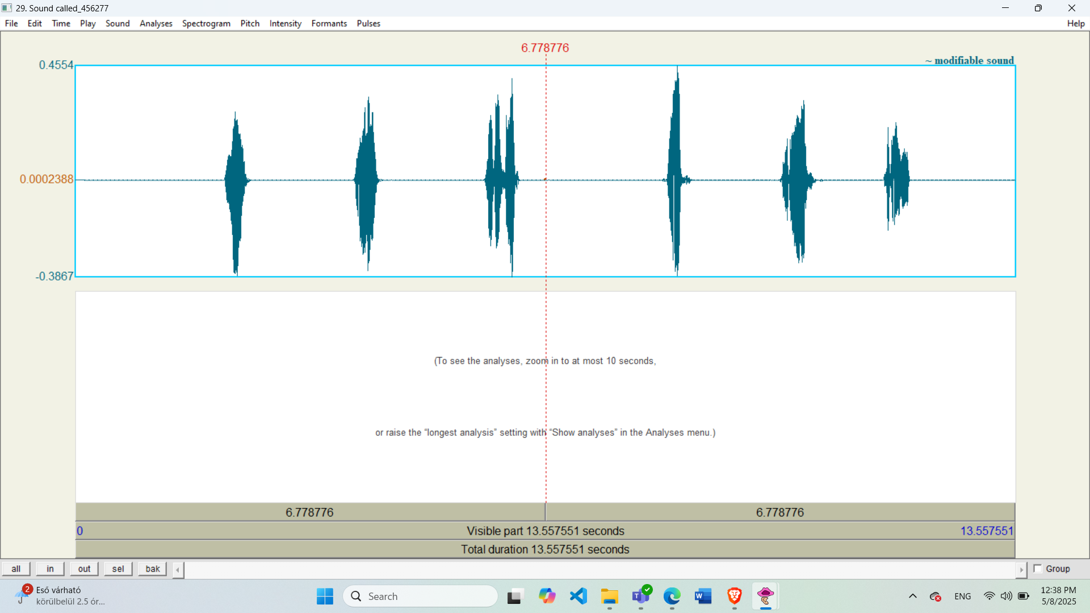

Attach the audio files!

C3.1 Audio Repair

Your task is to repair an audio file where the last sound of the word *"second"* is missing.

Available words for replacement from the original recording: [“David, record, Danube, award, speed, down, goods, yesterday, wedding, ending”]

Generate the missing sound using TTS.

Cut the "d" sound from one of the available words and replace the missing portion in the sentence

*[“Sixty seconds are up.”]*

Insert the amplitude-time images before and after the modification.

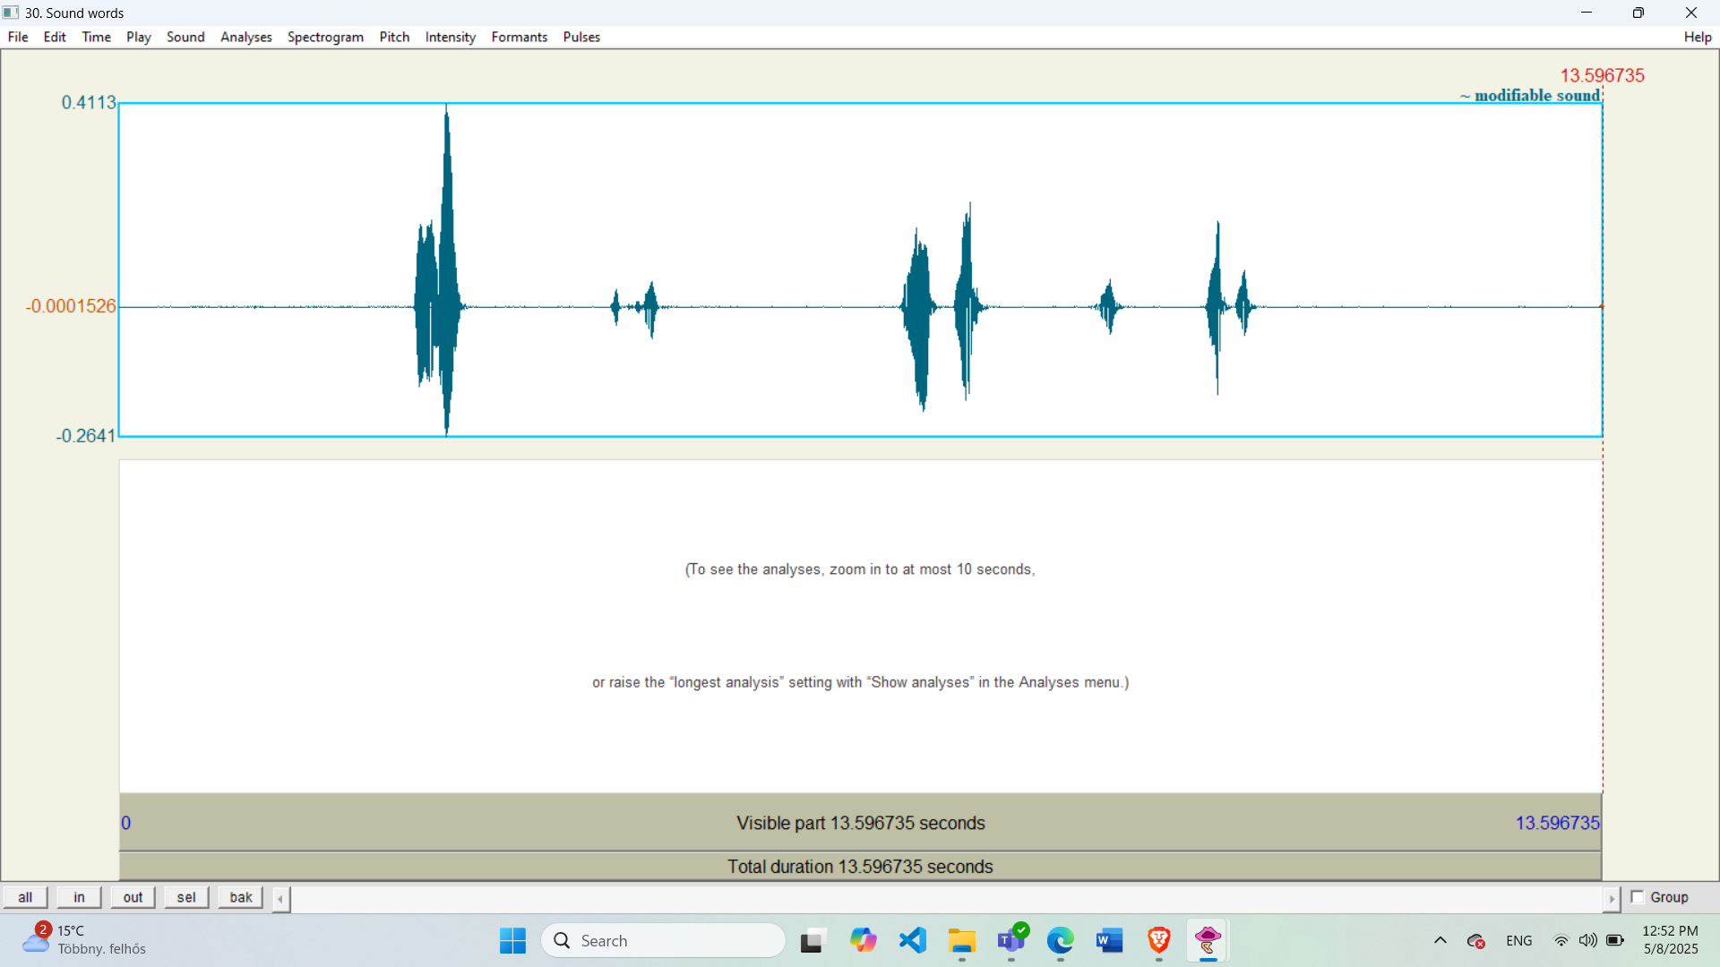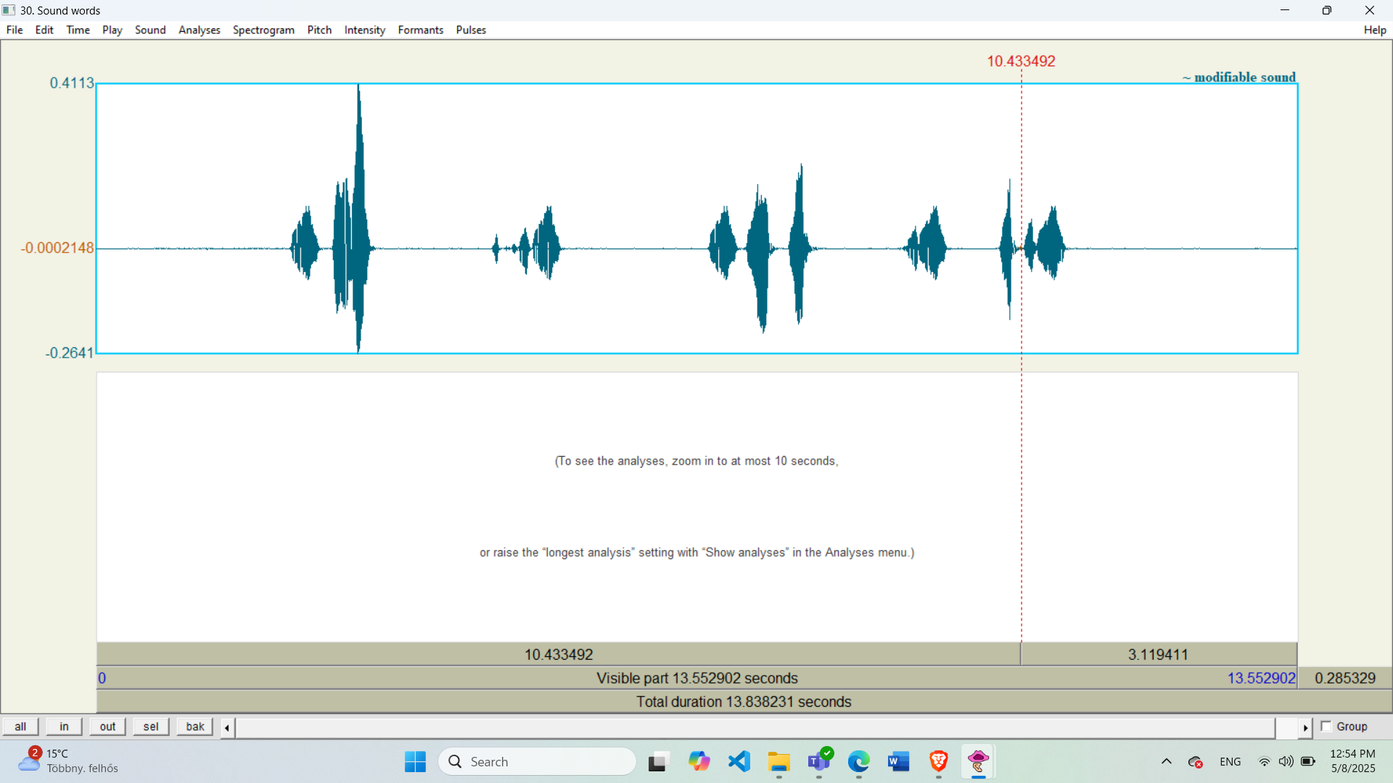

Attach the audio files.

C3.2 Audio Surgery

Stretching the 'Tata' sound sequence. Say it aloud or generate it with TTS! Stretch the **"tata"** sound manually to produce **"tatta."**

Insert the amplitude-time images before and after the modification here!

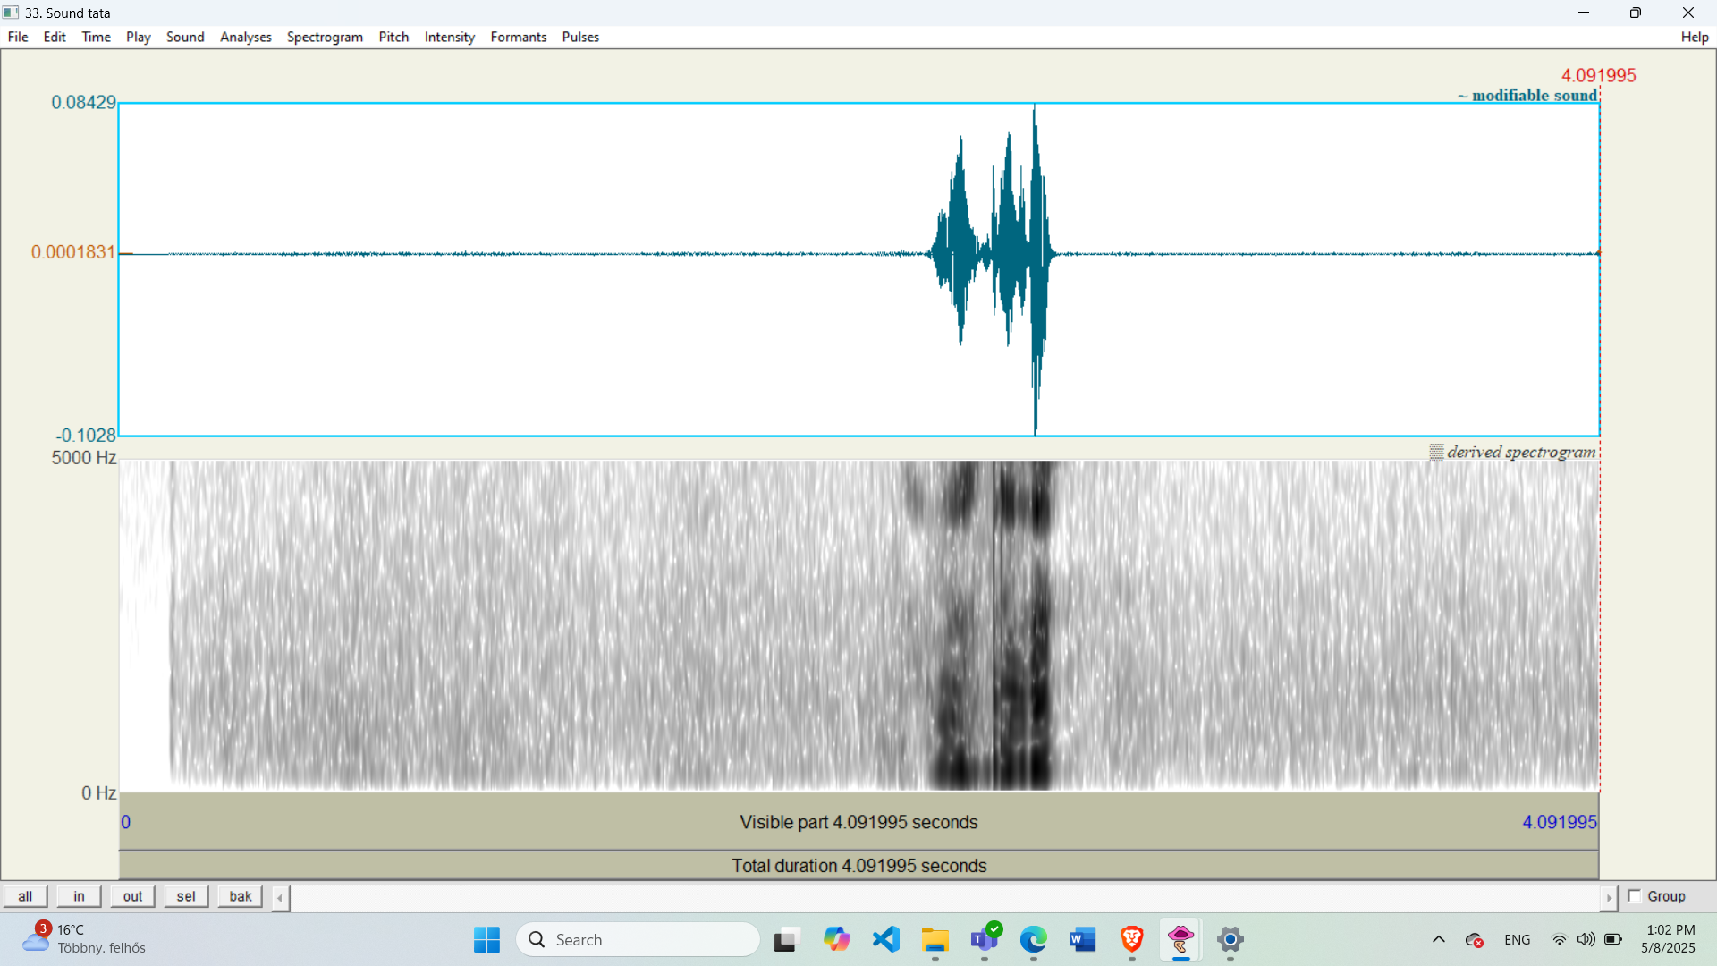

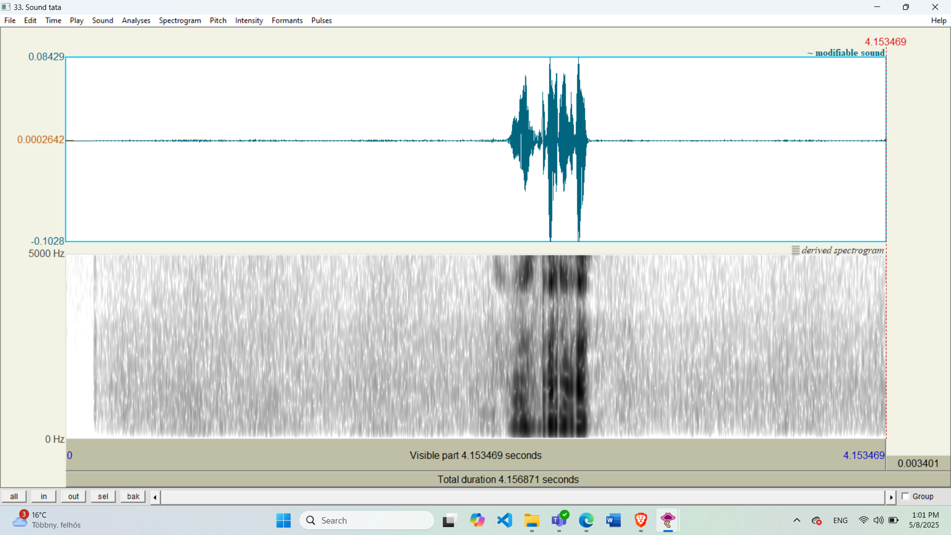

Attach the audio files.